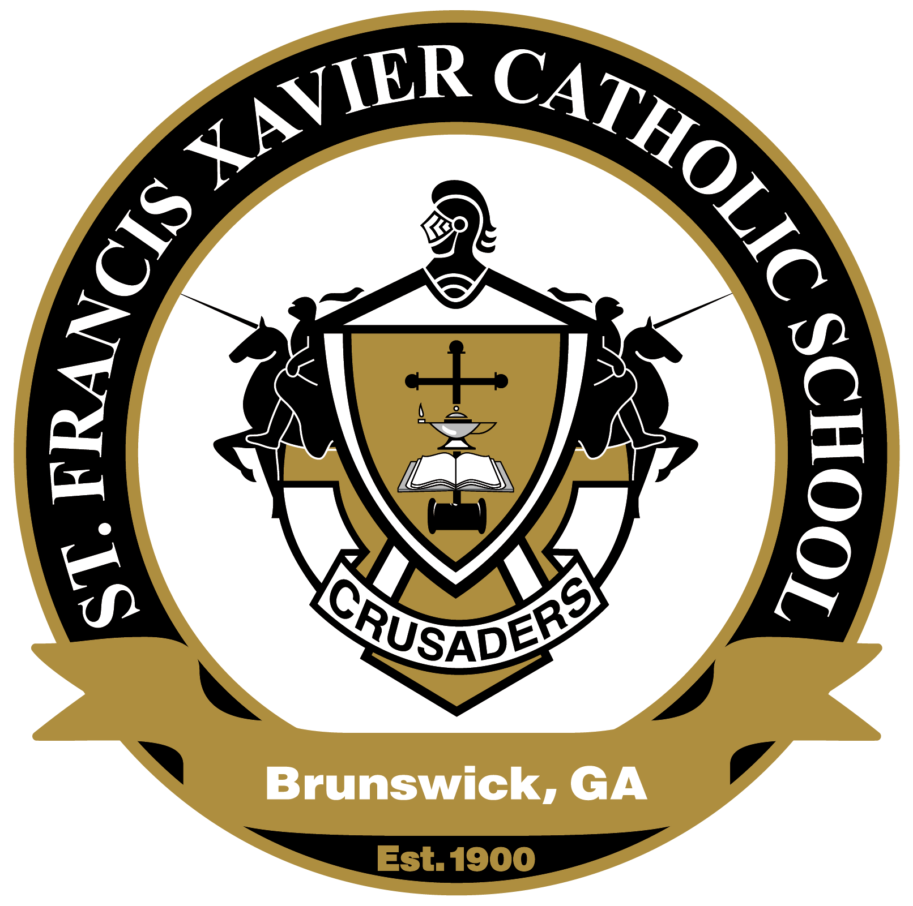
St. Francis Xavier Catholic School
2022 Crusaders Bash
Saturday, February 26, 2022

2022 Donation Form
Donor Information:
Donor or Business Name: Donor Contact Name:

Business address, city, state, zip code:

Work Phone: Cell Phone:

Email Address: Company Website:

Item Information:
Item: | Estimated Dollar Value:
Item Description- Include Quantity, Size, Color, Number of Persons, Days/Nights, and All Restrictions:

Check Appropriate Box:

☐ Delivery of item by Donor ☐ Donor to provide Certificate
☐ Item needs to be picked up ☐ Committee to create Certificate
☐ Promotional material provided by Donor

Donor Signature: |  | Date:
Please make a copy of this form for your tax records. A thank you letter will be sent to you post event to serve as your receipt. Please return forms by February 16, 2022

For more information or to arrange for pick-up, please contact the event chair
:
Stephanie D’Amico (912-399-9296, sgdamico26@gmail.com)
Mail or drop off your sponsorship:
St. Francis Xavier Catholic School
Attn: 2018 Crusaders Bash
1121 Union Street
Brunswick, GA 31520
Federal Tax ID #: 581584133

